**1 Internship Count by Domain (Title)**

SELECT title, COUNT(*) AS internship_count

FROM internships

GROUP BY title

ORDER BY internship_count DESC;

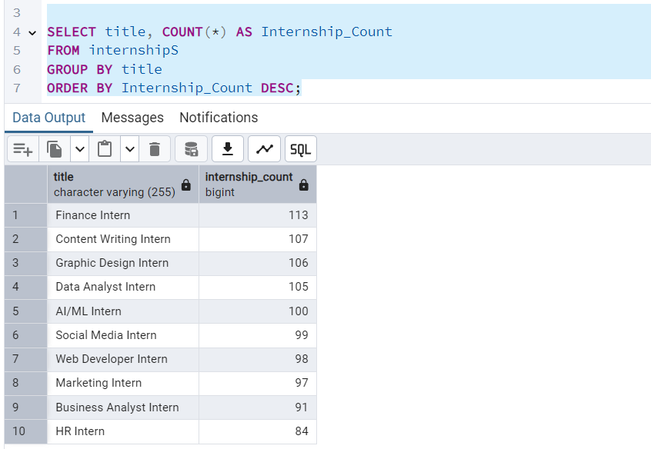

**2 Location-wise Internship Distribution**

SELECT location, COUNT(*) AS total_internships

FROM internships

GROUP BY location

ORDER BY total_internships DESC;

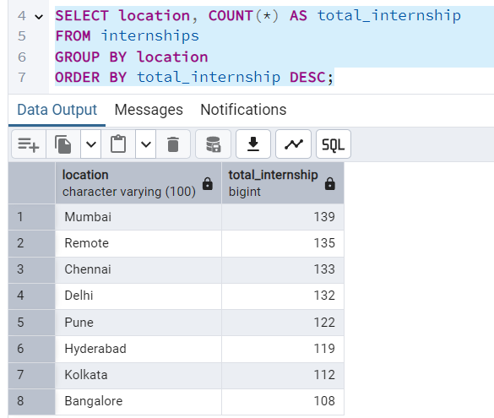

**3 Mode of Internship (Online/Offline/Hybrid)**

SELECT mode, COUNT(*) AS count_by_mode

FROM internships

GROUP BY mode

ORDER BY count_by_mode DESC;

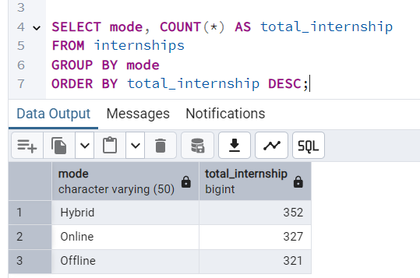

**4 Average Stipend by Internship Title**

SELECT title, ROUND(AVG(stipend), 2) AS avg_stipend

FROM internships

GROUP BY title

ORDER BY avg_stipend DESC;

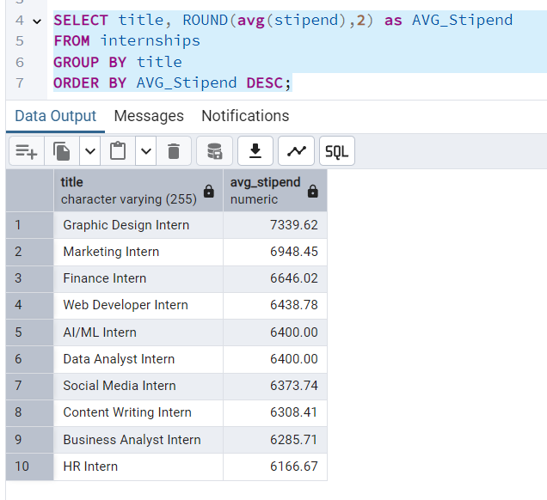

**5 Most In-Demand Skills (Individual Keywords)**

SELECT TRIM(UNNEST(STRING_TO_ARRAY(skills, ','))) AS skill,

COUNT(*) AS skill_count

FROM internships

GROUP BY skill

ORDER BY skill_count DESC

LIMIT 20;

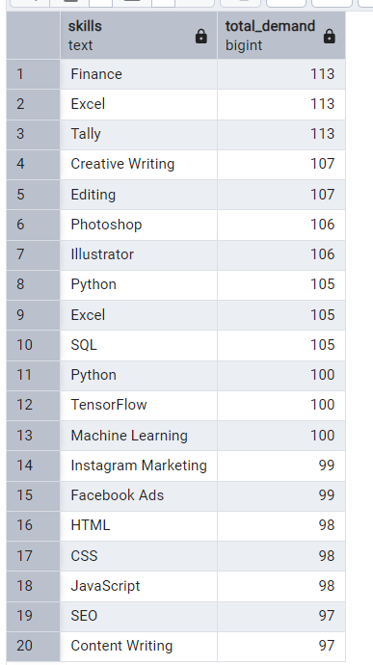

**6 Internship Duration Trend**

SELECT duration, COUNT(*) AS total

FROM internships

GROUP BY duration

ORDER BY total DESC;

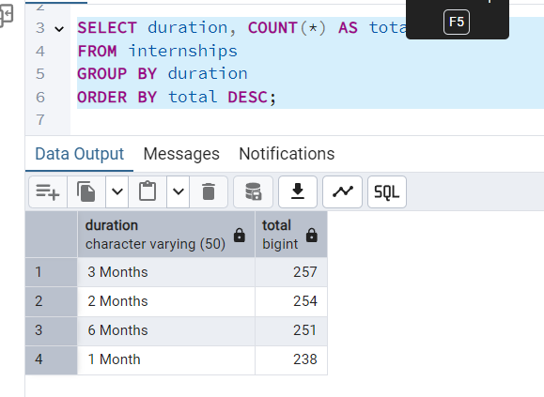

**10 KPI Summary Metrics**

-- Total Internships

SELECT COUNT(*) AS total_internships FROM internships;

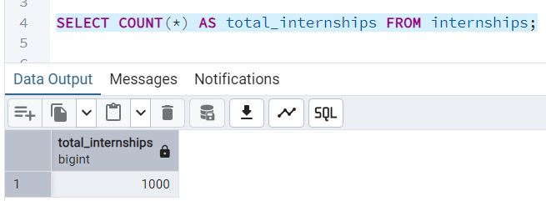

-- Average Stipend

SELECT ROUND(AVG(stipend), 2) AS average_stipend FROM internships;

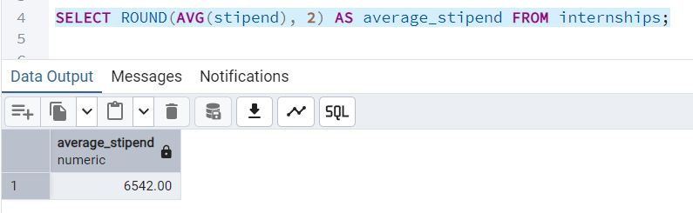

-- Online Internships

SELECT COUNT(*) AS online_internships FROM internships WHERE mode = 'Online';

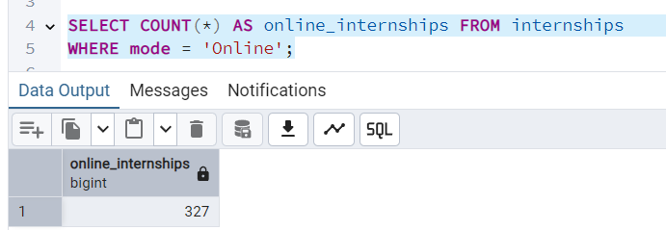

-- Count of internships with deadline in next 7 days

SELECT COUNT(*) AS upcoming_deadlines FROM internships

WHERE deadline BETWEEN CURRENT_DATE AND CURRENT_DATE + INTERVAL '7 days';

